SEQUENCE OF OPERATION FOR NETRASAGAR POS APPLICATION

1. Click on NETRASAGAR application on desktop.
2. Enter Username and Password provided by MEGASOFT SYSTEM.

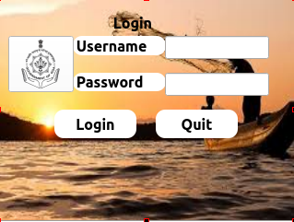

1. Click on Login button and user will be navigated to the DASHBOARD.

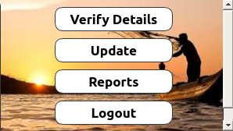

1. Every day for the first time its mandatory for the user to update the pos. Message will be displayed “Please Update Database to Continue”.Press Update button to update the device.

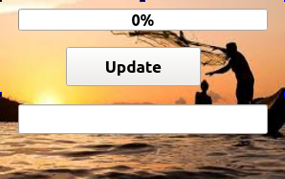

1. After syncing database, user can now perform the operations on the pos.
2. To verify VESSEL/CREW RFID card ,click on Verify Details button and place the RFID card in the RFID FIELD and press Read RFID Card button.
3. Details in the card will be displayed on the screen.
4. Comment can be written if any in the comment section.
5. To save the details user can press SAVE button.
6. Similarly GPS location of the device will be captured when saving pass.Please ensure that the device is open to sky for accurate GPS positioning.

**Crew Details View Form**

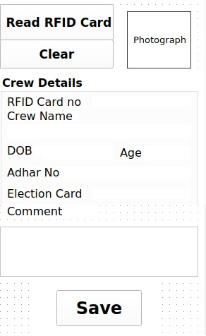

Crew RFID card contains the following details about the crew

* Crew passport size photograph
* Crew name
* Date of Birth
* AGE
* Adhaar No of crew
* Election Card no of crew

**Vessel Details View Form**

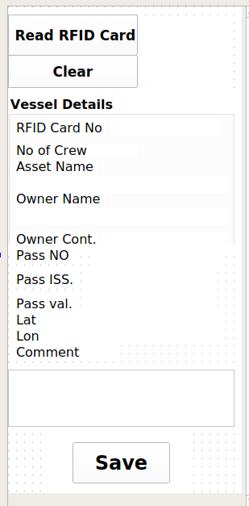

Vessel RFID card contains the following details about the vessel

* No of Crew on the vessel.
* Asset name (Vessel Name).
* Owner Name.
* Owner Contact Number.
* Pass No - if pass issued for vessel.
* Pass Issue date.
* Pass Validity - Depends upon the no of days the pass is issued for from the date of issue.
* Lat & Lon – Location where the card is scanned.

1. To view Reports click on REPORTS button on DASHBOARD.
2. User can update the data whenever there is a internet connection on the device.Once the data is uploaded it can be seen on the https://www.netrasagar.in in reports section.

**THANK YOU**